|  |
| --- |
| **Argentis Consulting** |
| **Apparel & Footwear** |
| Reports for SAP Marketing Documents Configuration |



**www.sapapparel.com**

Reports for SAP Marketing Documents Configuration

Here are the steps you need to follow to import Reports for SAP Marketing Documents Configuration

1. Open the Report and Layout Manager and click on import
2. In the First Step Browsw the ApparelCRAll.b1px fike and click on Next

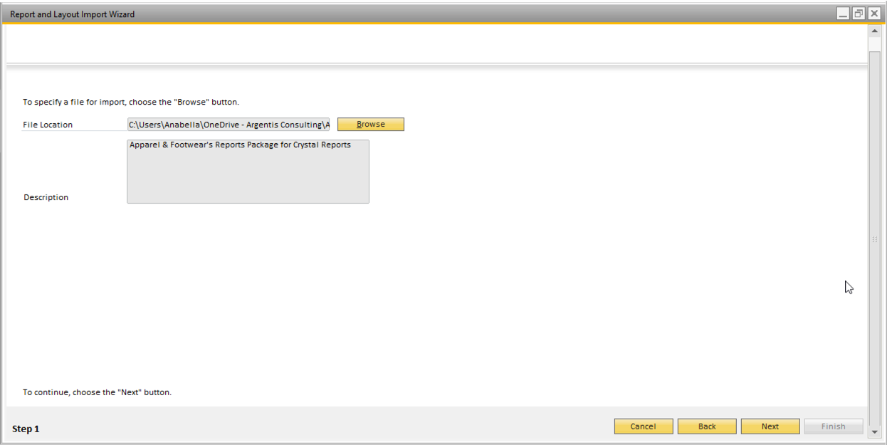

1. In the Second Step select the Apparel reports you want to import

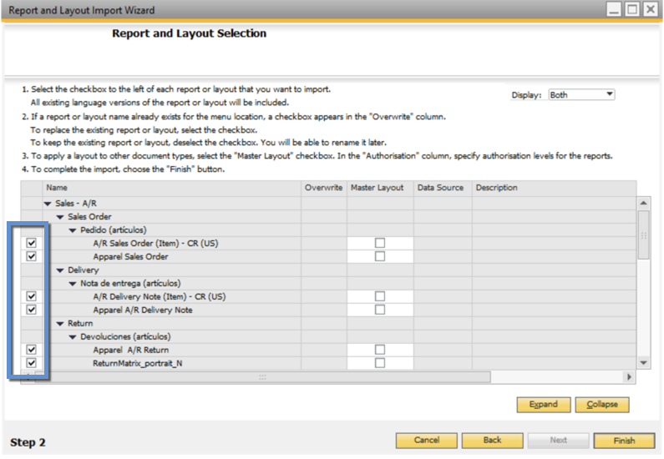

1. In the third Step click on Close
2. Open the desired Marketing Document and in the Layout and Sequence Set as Defaul the Apparel Report for the Marketing Document

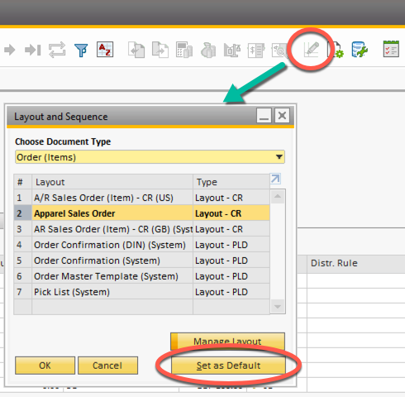



**www.argentisconsulting.com**

**Argentis Consulting** is dedicated to the development, distribution and support of recognized certified solutions for SAP Business One, as an SSP (Software Solution Provider) with a Gold Partner status.

**CONTACT INFORMATION**

|  |  |
| --- | --- |
| **USA**  9744 NW 45th Lane  Doral, FL 33178  info@argentisconsulting.com | **ARGENTINA**  Ávila y Zarate 2048  Cerro de la Rosas, Córdoba,  CP 5009  Córdoba - Argentina  info@argentisconsulting.com |
| **CARIBEAN**  City View Plaza – Suite 301  48 Road 165  Guaynabo, PR. 00968  Puerto Rico  caribe@argentisconsulting.com | **SPAIN**  C/ Juan Bravo N° 3 A 28006  Phone: (+34) 91 123 7263  Madrid - Spain  info@argentisconsulting.com |